Mediashippers Marketplace
Internal Training & Workflow Documentation
Step 1 — Title Creation & Metadata Initialization

Reference UI Screenshot
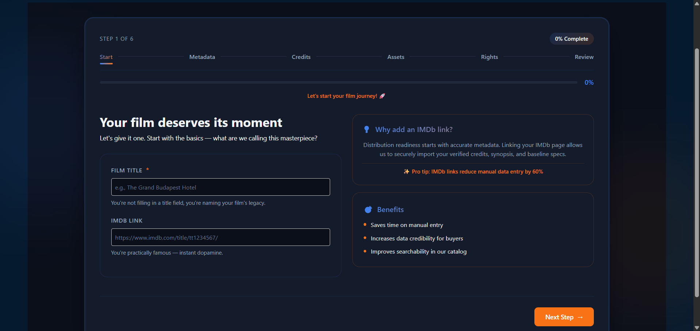
Figure 1.0 — Marketplace title creation interface used during content onboarding.

1. Overview
The Title Creation module is the first stage of the Mediashippers marketplace content onboarding workflow. This page is responsible for registering the core identity of a film, series, or entertainment asset before the platform proceeds into metadata enrichment, credits verification, artwork processing, rights management, and publishing review.
This workflow is commonly used by distributors, licensors, aggregators, production houses, and content acquisition teams when onboarding titles into the marketplace ecosystem.

2. Purpose & Core Workflow Philosophy
The platform is designed around structured metadata-driven licensing operations. The Title Creation stage ensures that all content entering the marketplace follows standardized naming conventions and verification pipelines before becoming visible to buyers or licensing partners.
- Improve metadata accuracy across the marketplace
- Reduce duplicate title submissions
- Support automated IMDb synchronization
- Increase buyer-side trust and discoverability
- Prepare titles for rights configuration and territory licensing

3. Title Creation Fields
Field | Type | Requirement | Description
Film Title | Text Input | Mandatory | Official name of the movie, series, or content asset.
IMDb Link | URL Input | Optional | IMDb URL used for metadata importing and verification.

4. Dummy Example Submission
Parameter | Value
Film Title | Echoes of Tomorrow
IMDb Link | https://www.imdb.com/title/tt18456321/
Genre | Sci‑Fi Thriller
Language | English
Runtime | 124 Minutes
Release Year | 2025
Content Type | Feature Film
Production Country | United States

5. IMDb Integration Standards
IMDb integration acts as an optional metadata acceleration layer within the Mediashippers onboarding pipeline. When a valid IMDb title URL is provided, the platform attempts to initialize supporting metadata fields automatically.
- Cast and crew information may be imported automatically
- Runtime and release year are validated against public metadata
- Poster artwork references may be matched internally
- Buyer-facing discoverability scores improve for verified metadata
- Metadata confidence ratings are increased for verified titles

6. Validation & Compliance Rules
Before the user can proceed to the next onboarding stage, the system performs multiple automated validation checks to ensure marketplace consistency.
- Film title cannot remain empty
- Duplicate title detection engine is automatically enabled
- IMDb URLs must follow approved imdb.com/title format structures
- Unsupported characters or malformed titles may be rejected
- Metadata synchronization starts immediately after successful validation

7. Workflow Progression
After successful completion of the Title Creation stage, the onboarding workflow continues into deeper content configuration modules.
- Start
- Metadata
- Credits
- Assets
- Rights
- Review

8. Internal Notes for Interns
This document is intended for internal onboarding, workflow understanding, and UI familiarization purposes only. The films, metadata examples, and licensing scenarios included in this document are fictional and created strictly for training simulations.
Interns reviewing this workflow should understand how metadata collection impacts downstream licensing operations, content discoverability, rights management, and marketplace validation systems.
CONFIDENTIAL — MEDIASHIPPERS INTERNAL TRAINING MATERIAL

